

**SCHOOL DISTRICT NO. 62 (SOOKE)**

3143 JACKLIN ROAD,

VICTORIA, BRITISH COLUMBIA • V9B 5R1

TELEPHONE: 250-474-9800 FAX: 474-9893

WEBSITE: WWW.SD62.BC.CA

May 29, 2024

Dear Parents/Guardians:

The 2024 – 25 School Calendar is attached for your information. Please find below the specific school information for **Centre Mountain Lellum Middle School** for the **2024 -25 school year**.

**School Operation Details By Day for 2024 - 25:**

1. Length of School Day: 8:40am – 2:41pm

2. School Office Hours: 8:00am – 4:00pm

1. Hours of instruction in a school week: Middle School – 25 hrs./55 min.
2. Minimum Hours of Instruction Per Year: (as per School Calendar Regulation (BC Reg.)

Gr. 1-7 – 878 hrs./yr; Gr. 8-12 – 952 hrs./yr

1. Number of Breaks: one 15 minute recess/break. Time: 9:31am – 9:46am
2. Lunch Break: 11:30am – 12:05pm
3. Early Dismissal (Three Hours for All Schools) – Parent-Teacher Interviews/Conferences:

* Thurs., Nov. 21
* Thurs., Apr. 10, 2025

Should you have any questions about the School Calendar or operational details, please contact your school Principal.

Yours respectfully,

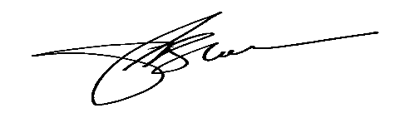

Paul Block

Superintendent of Schools

attachments