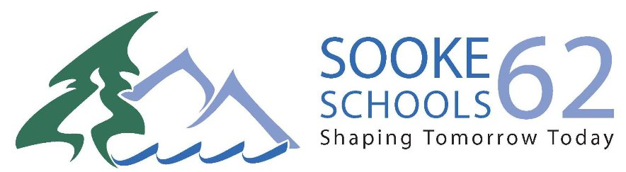

**SCHOOL DISTRICT NO. 62 (SOOKE)**

3143 JACKLIN ROAD,

VICTORIA, BRITISH COLUMBIA • V9B 5R1

TELEPHONE: 250-474-9800 FAX: 474-9893

WEBSITE: WWW.SD62.BC.CA

June 10, 2022

Dear Parents/Guardians:

The 2022 – 23 School Calendar is attached for your information. Please find below the specific school information for **Centre Mountain Lellum Middle Schoo**l for the **2022 -23 school year**.

**School Operation Details By Day for 2022 - 23:**

1. Length of School Day: **8:40am – 2:41pm**

2. School Office Hours: **8:00am – 4:00pm**

1. Hours of instruction in a school week: **25 hrs./55 min.**
2. Minimum Hours of Instruction Per Year: **Gr. 1-7 – 878 hrs./yr; Gr. 8-12 – 952 hrs./yr)**
3. Number of Breaks: **One 15-minute recess/break**  Time: **9:31am – 9:46am**
4. Lunch Break: **11:30am – 12:05pm**
5. Early Dismissal (Three Hours for All Schools) – Parent-Teacher Interviews/Conferences:

* Thurs., Nov. 24, 2022
* Thurs., Apr. 20, 2023

1. **Other information of interest/importance to parents:**

Tuesday, September 6, 2022 Staff only for safety orientation

Wednesday, September 7, 2022 Grade 6 only from 8:40am - 11:00am

Thursday, September 8, 2022 Grade 7 only from 8:40am – 11:00am

Grade 8 only from 12:30pm – 2:41pm

Friday, September 9, 2022 Full day for all 8:40am – 2:41pm

Should you have any questions about the School Calendar or operational details, please contact your school Principal.

Yours respectfully,



Scott Stinson

Superintendent of Schools

attachments